**Wire Routing Assembly Views**

*Vent Wires*

1. Battery Power Wire – 801-00033 – 3”

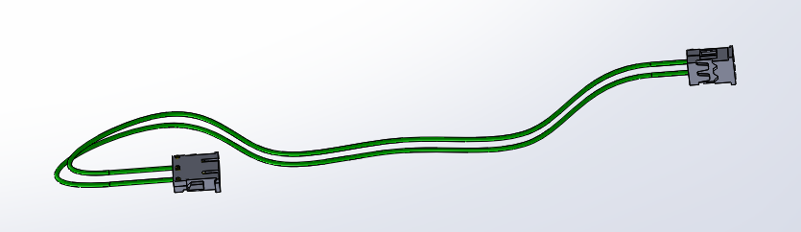

Step 1.1: Route wire from battery PCB to 2-pin molex connector on Vent PCB as shown

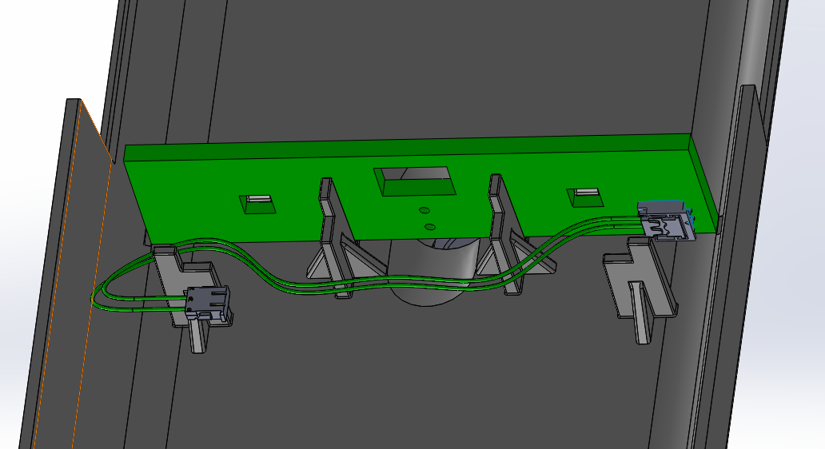

Vent PCB (hidden)

)

Battery PCB

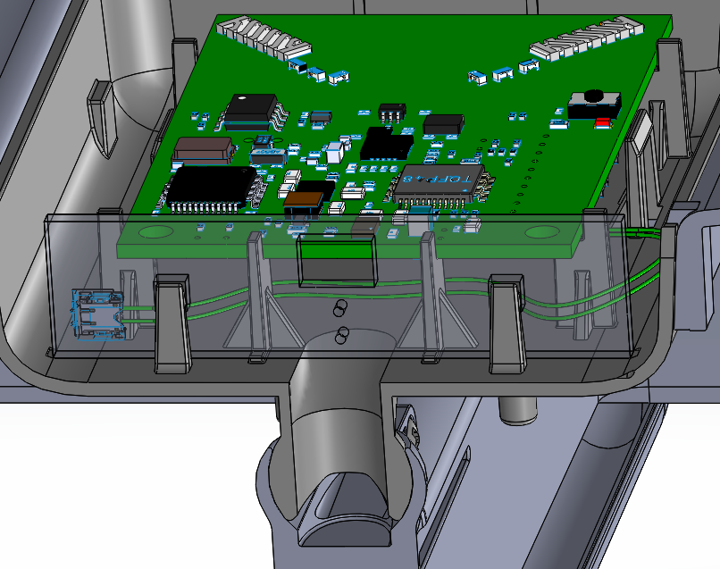 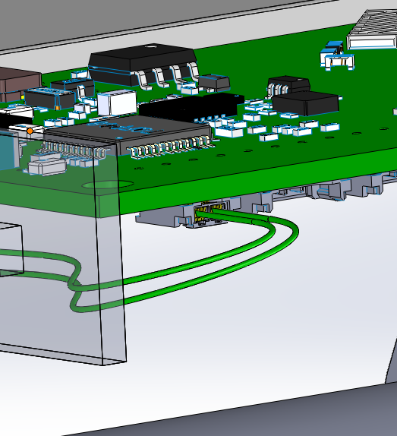

Vent PCB

2. Motor Wire - 801-00034 – 9.25”

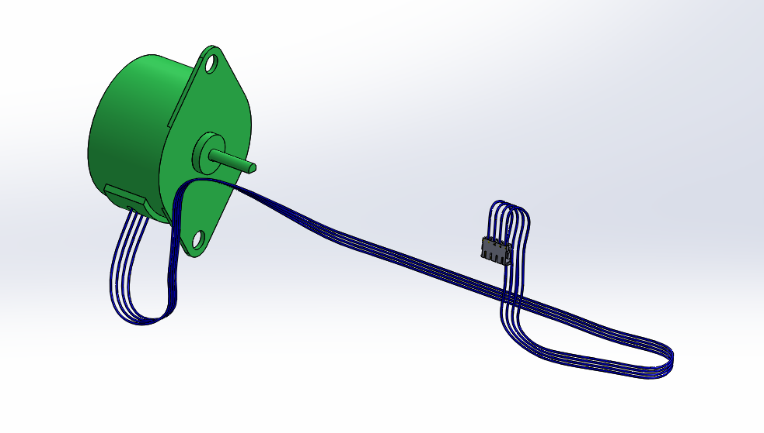

Step 2.2: Route wire into drivetrain tunnel and through the drivetrain.

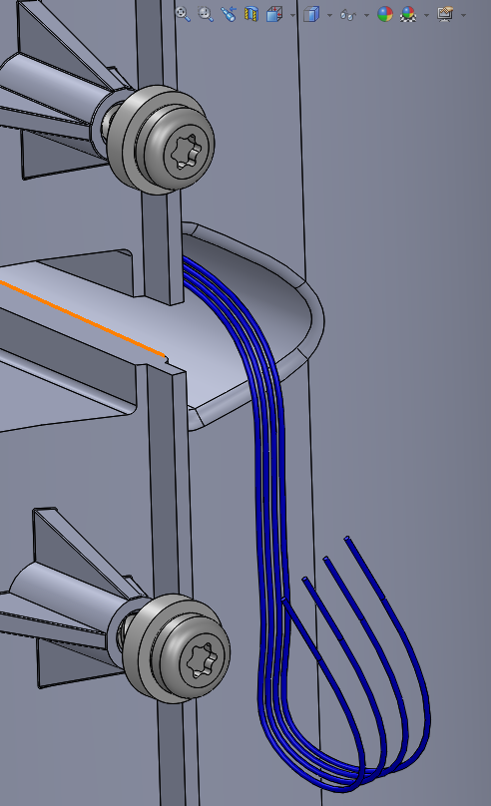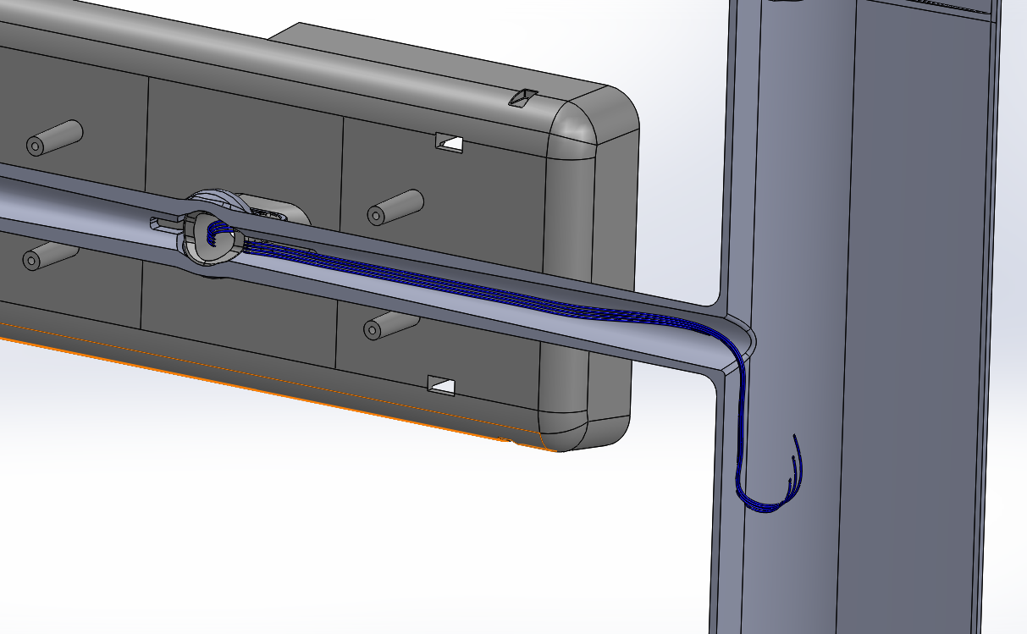

Step 2.3: Pull wire up through balljoint using tweezers or hook.

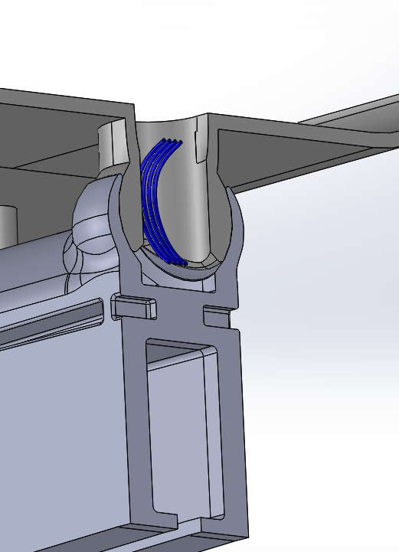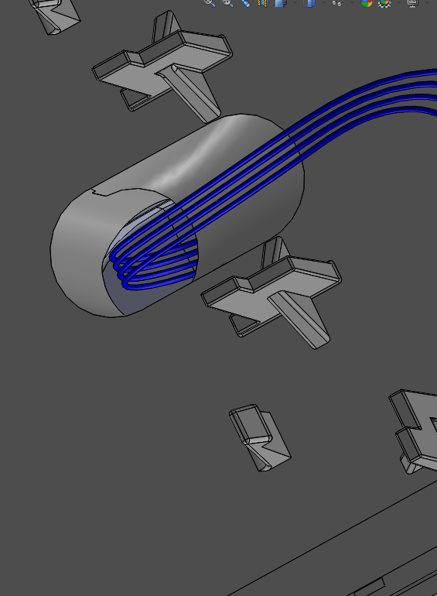 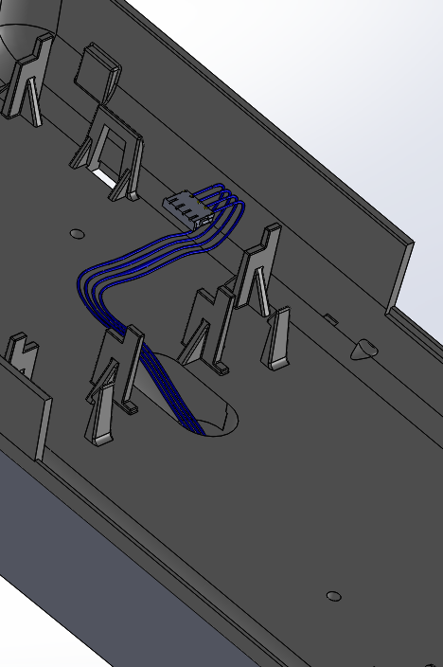

Step 2.4: Attach to center 4-pin female molex on Vent PCB. Excess wire is tucked beneath PCB if necessary.

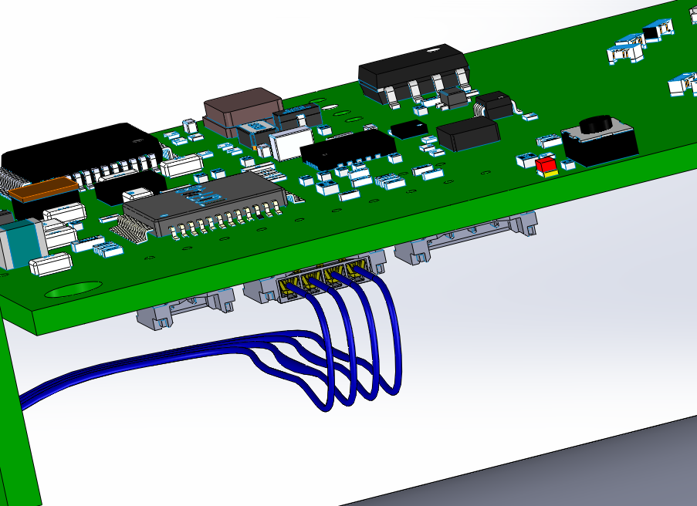 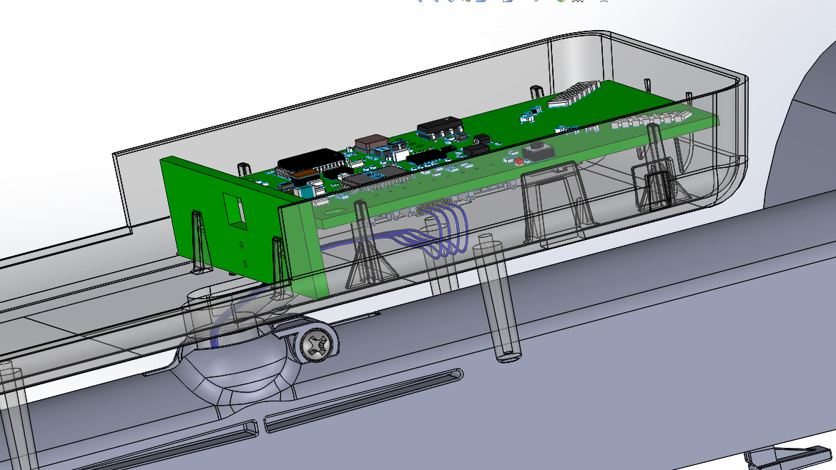

3. Pressure Sensor Wire – 801-00053- 16”

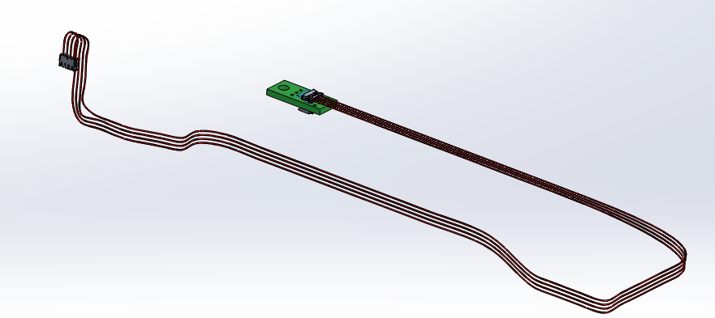

Step 3.1: Route wire into the balljoint opening and through the drivetrain tunnel.

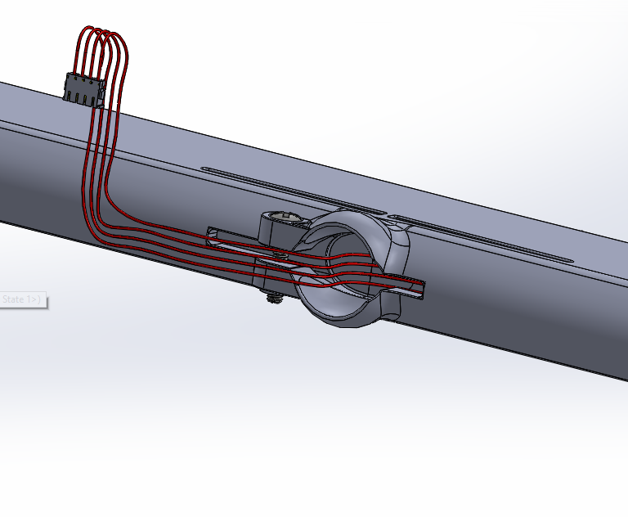 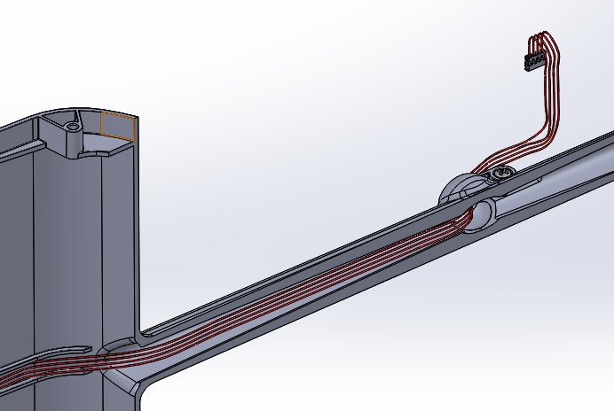

Step 3.2: Route wire out of drivetrain tunnel and behind bushing

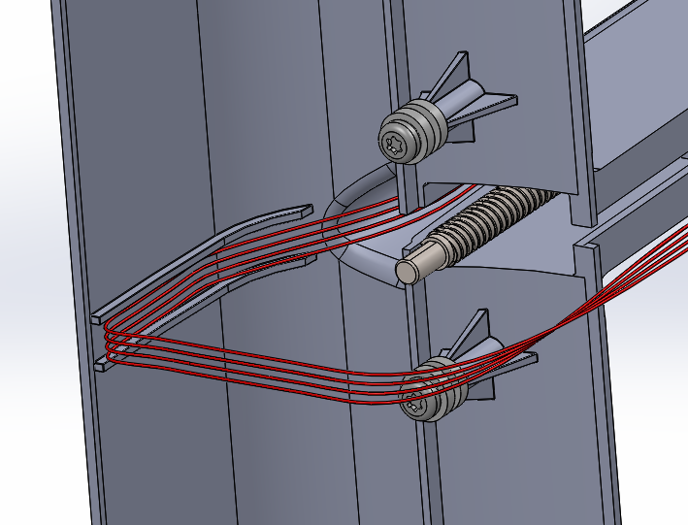 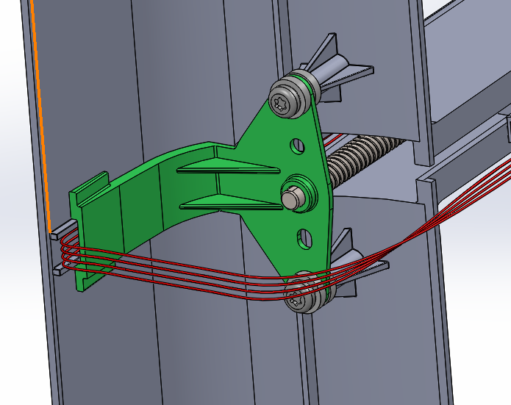

Step 3.3: Route wire through outer box while inserting drivetrain into outer box

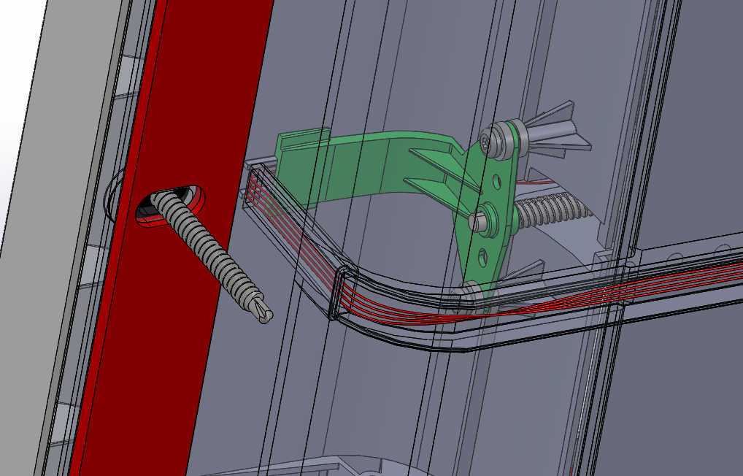 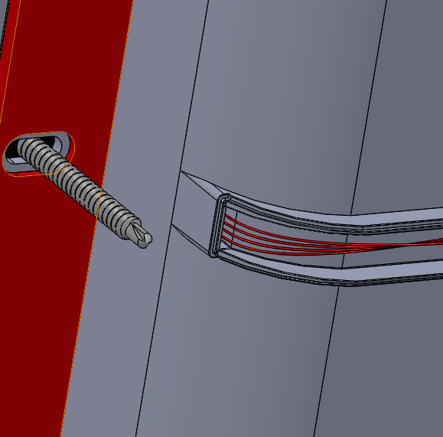

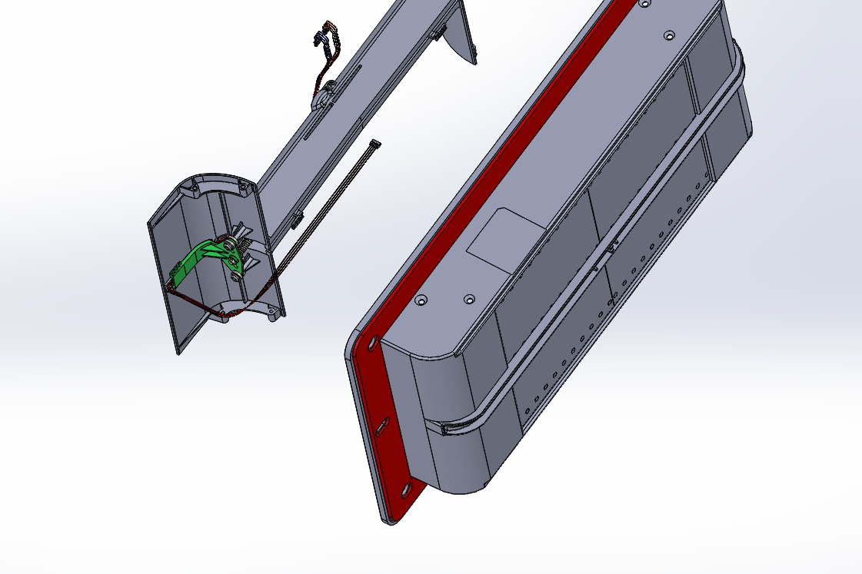

Inserting drivetrain into outer box

Step 3.4: Route wire to pressure sensor. Then attach pressure sensor cover.

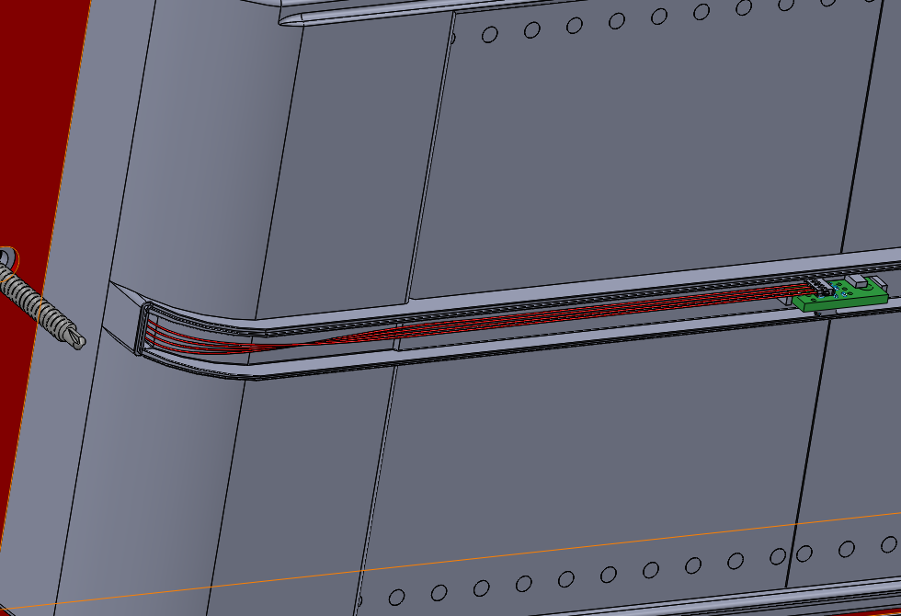 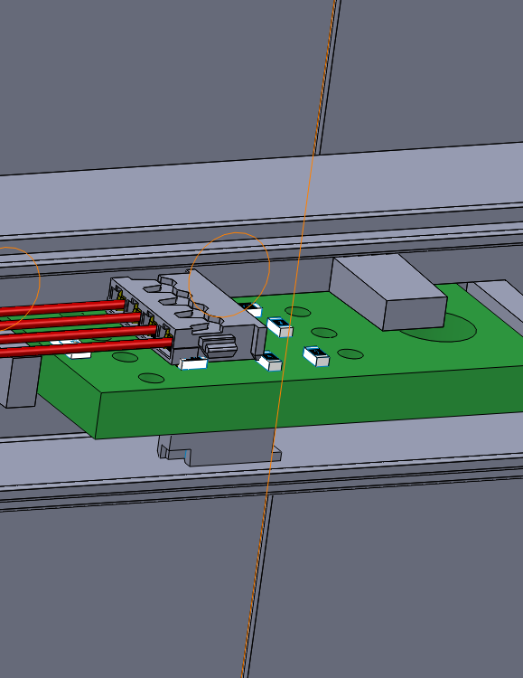

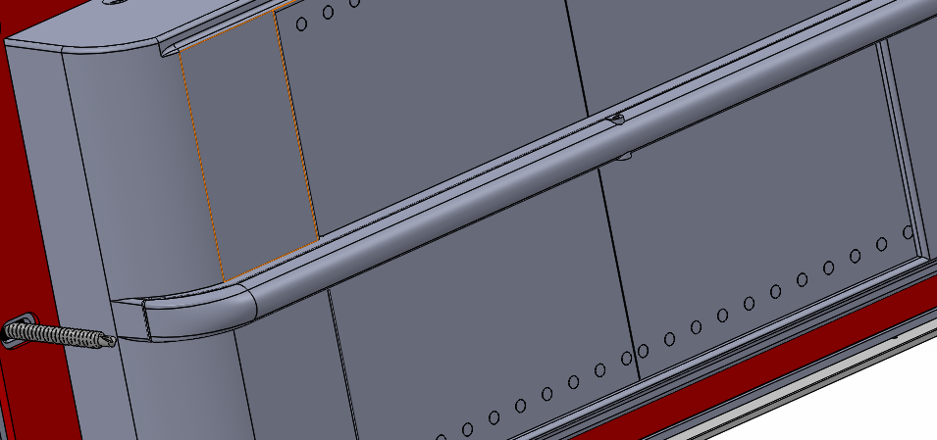

Attached Pressure Sensor Cover

Step 3.5: Attach balljoint faceplate. Route wire through balljoint hole. Same as step 2.3.

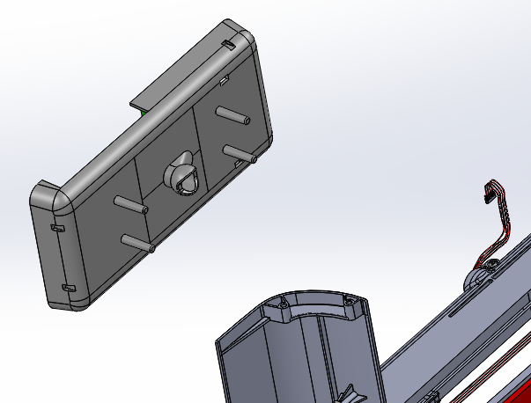 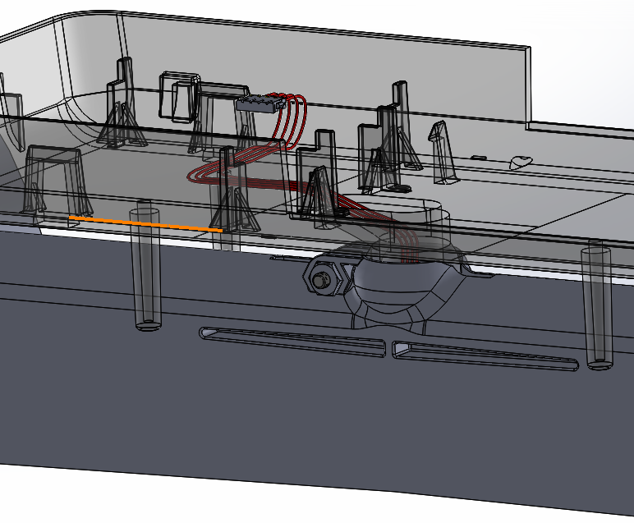

Step 3.6: Attach to outer 4-pin female molex connector on Vent PCB. Extra wire can be tucked under PCB if necessary.

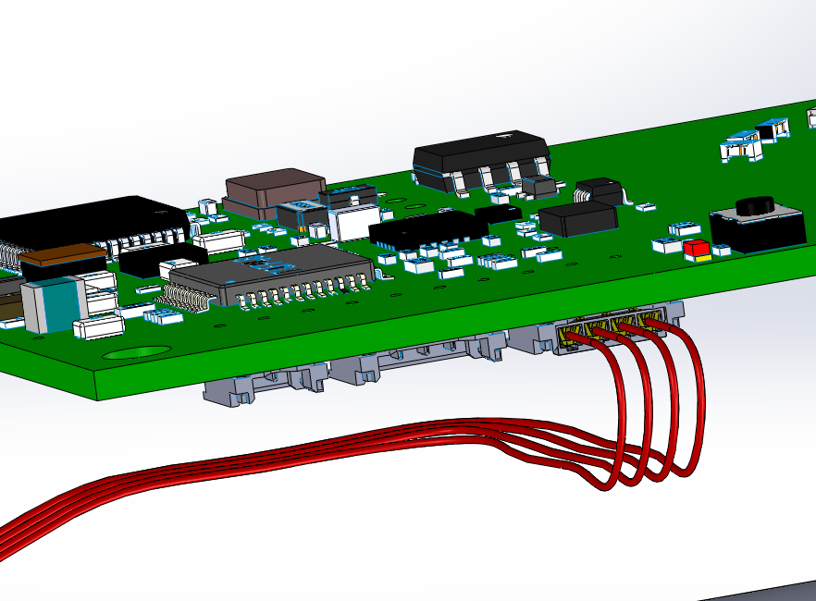 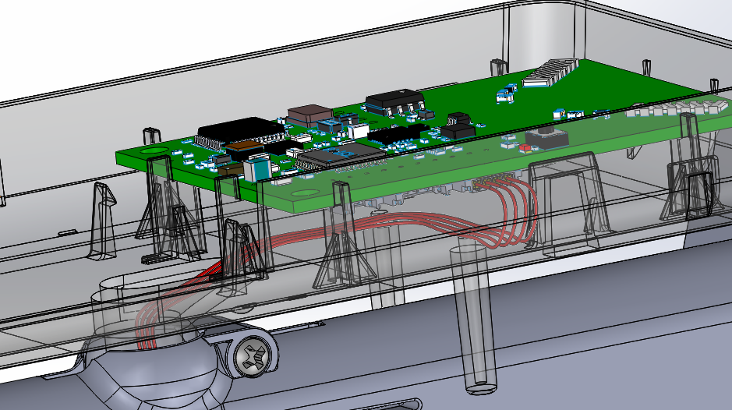

*Wall Sensor Wires*

4. Sensor Ring Wires – 801-00050 – 1.75”

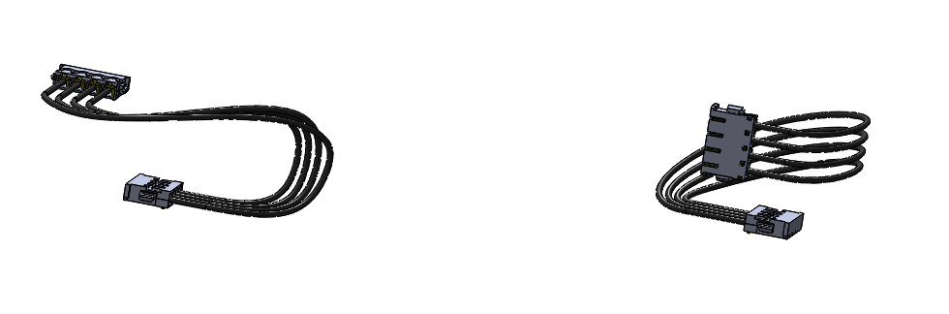

2 instances

Step 4.1: Route harnesses from sensor ring to pressure and temperature boards as shown.

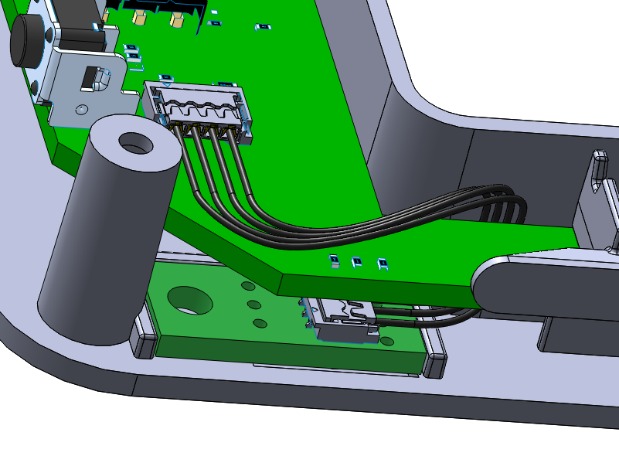 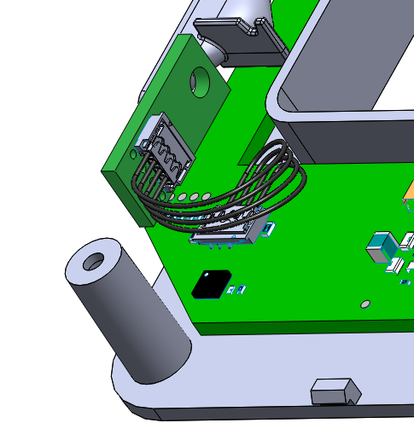

Temperature Sensor PCB

Pressure Sensor PCB

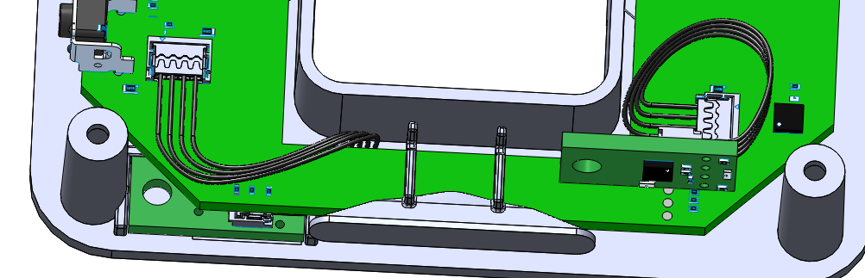

5. Power Prong Wires – 801-00049 – 1.5”

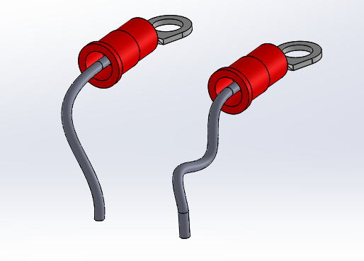

Step 1: Screw connectors in. Route to power core PCB as shown

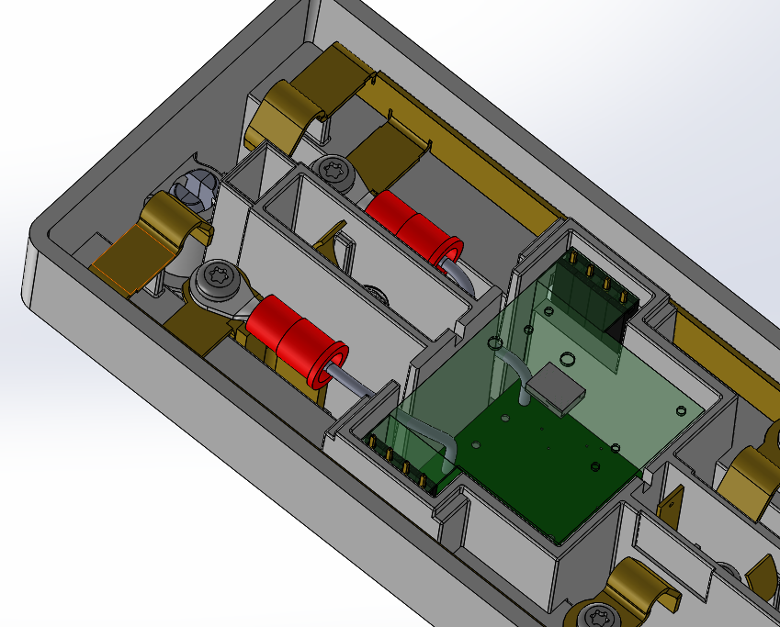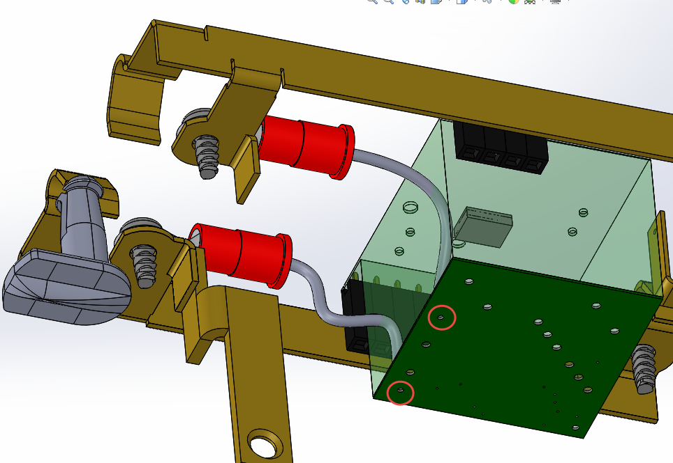

2 screws